HPE Container Platform – Kubernetes Application Image Development

Lab Solution Worksheet

Deploy “Springboot” Kubernetes application via web terminal 2

Build Docker Image and push to Docker Hub 2

Create Dockerfile 2

Build Docker Image 2

Deploy Docker Image to Docker Hub 3

Deploy Application in HPE Container Platform 4

Login 4

Accessing Application 8

# Deploy “Hello World” Kubernetes application via web terminal

For this initial lab, you will access the HPE Container Platform UI, the local terminal (SSH session), and other activities to prepare for the forth coming lab scenarios.

## Deploy Application in HPE Container Platform

### Login

1. Login to HPE Container Web UI

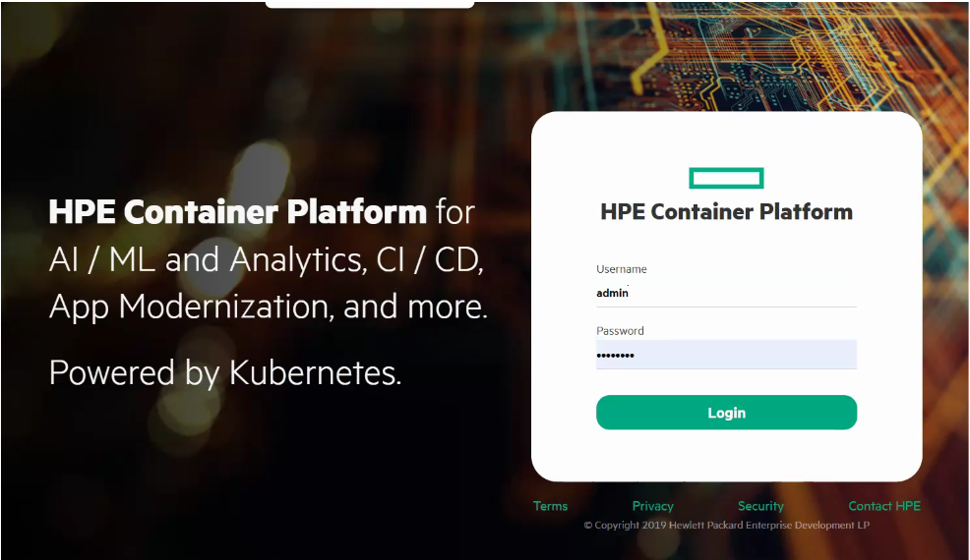

1. From left-hand menu, click on **KUBERNETES**
2. Click on **Tenants** and enter any tenant

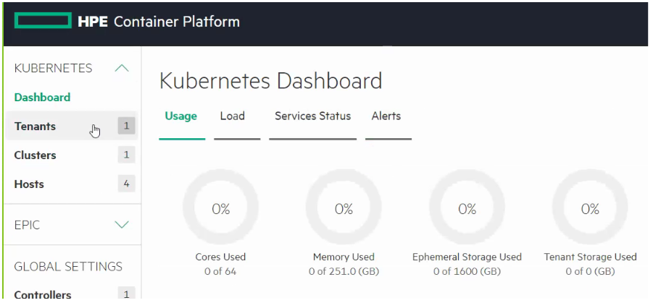

1. Click on **Applications**

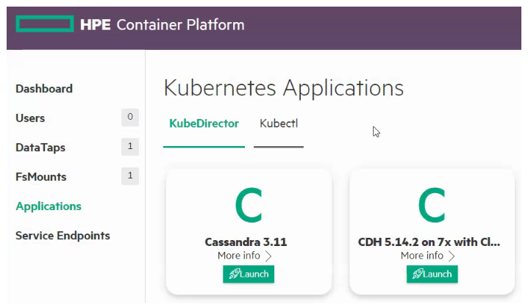

1. Open Web terminal form below

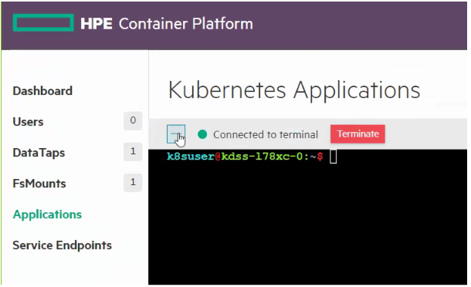

1. Create a directory for the application & navigate to it

k8suser@kdss-178xc-0:~$ mkdir helloworld

k8suser@kdss-178xc-0:~$ cd helloworld



1. Create a YAML file

K8suser@kdss-178xc-0:~$ vi app.yml

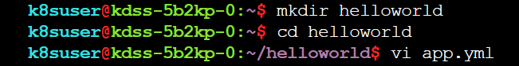

1. Add the following content to the YAML file

apiVersion: apps/v1

kind: Deployment

metadata:

name: hello-world

spec:

selector:

matchLabels:

run: load-balancer-example

replicas: 2

template:

metadata:

labels:

run: load-balancer-example

spec:

containers:

- name: hello-world

image: gcr.io/google-samples/node-hello:1.0

ports:

- containerPort: 8080

protocol: TCP

1. Save and exit the file
2. Execute the YAML file using kubectl command
3. k8suser@kdss-5b2kp-0:~/helloworld:~$ kubectl create –f app.yaml

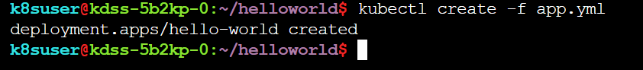

1. Create a web service YAML file to expose the application

k8suser@kdss-178xc-0:~$ vi app-svc.yaml



1. Add the following content to the YAML file

apiVersion: v1

kind: Service

metadata:

name: springboot-app-svc

labels:

hpecp.hpe.com/hpecp-internal-gateway: "true"

spec:

ports:

- name: prime-service

port: 80

targetPort: 9000

selector:

app: springboot-app

type: NodePort

1. Execute the YAML file using kubectl command

k8suser@kdss-178xc-0:~$ kubectl apply –f /home/k8suser/primenumber/app-svc.yaml

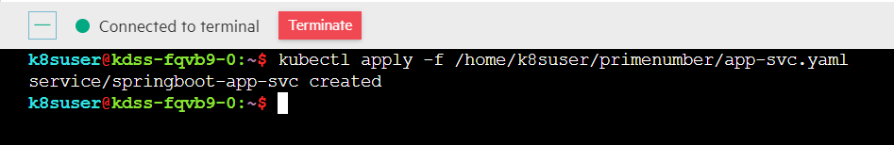

1. This procedure launches a browser-accessible web service application. You can find the external link details by executing the following Kubectl command

k8suser@kdss-178xc-0:~$ kubectl describe services

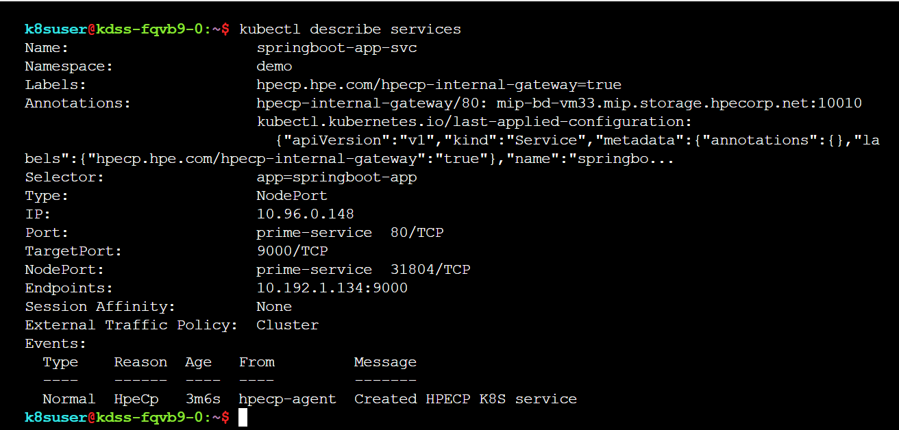

### Accessing Application

1. Use the Gateway hostname and port to access the application, provide input (any prime or non-prime number) and it will return True or False

